**Using Parchment to send your transcript to a college, university or other organization:**

1. **Log into your account at** [**www.parchment.com**](http://www.parchment.com)
   1. **Your username is your personal email. (Let me know if you forget which email you used to set up your account. I can look this up for you.)**
   2. **Click on FORGOT MY PASSWORD if you need to reset. (I do not have the ability to reset passwords.)**
2. **Click on *ORDER***



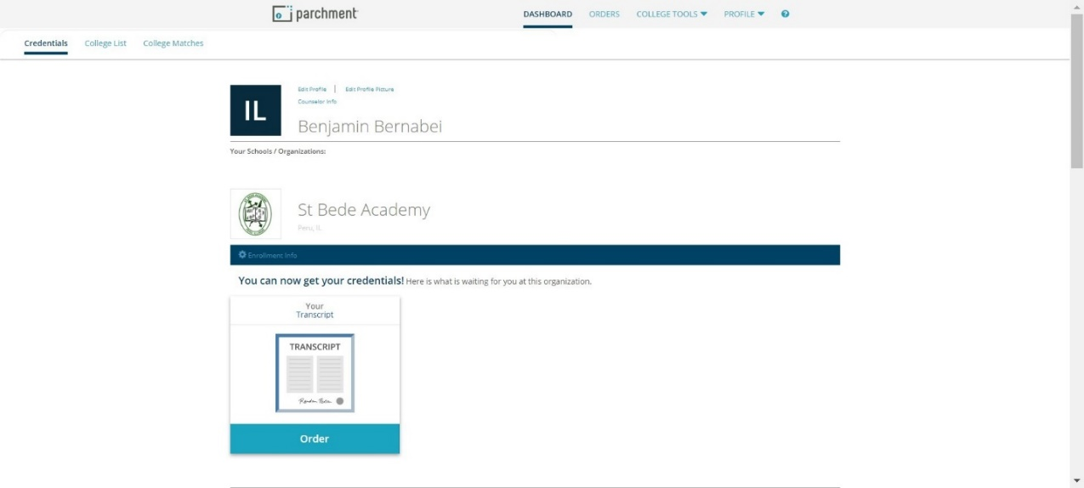







1. **Select a Destination: Click on *An Academic Organization, Admissions Office……..***
2. **Enter the name of the college/organization where you want your transcript to be sent and click *SEARCH*.**

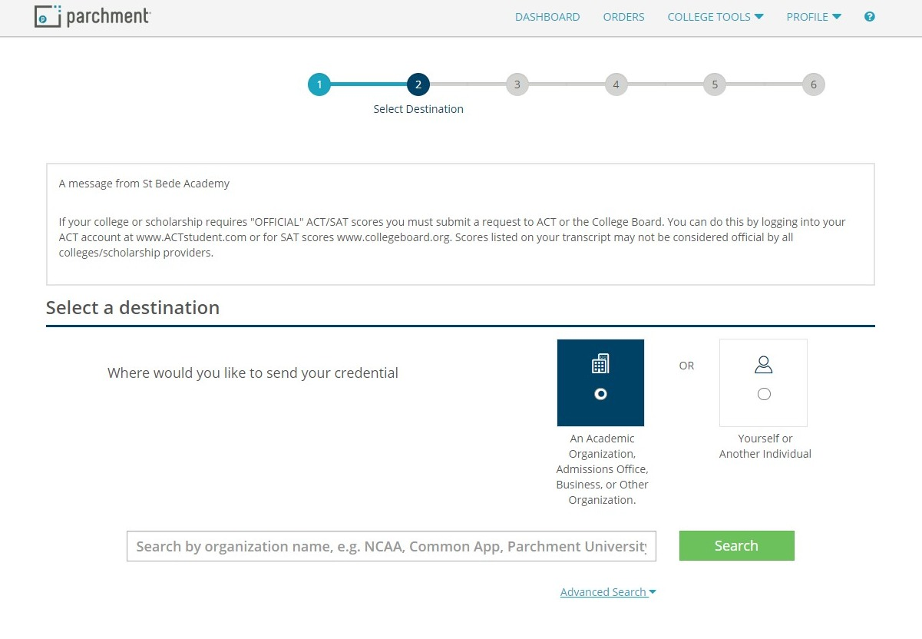



**3.**

**4.**



1. **When do you want your transcript sent?**

**\*\* Hold for Grades –** your transcript will be sent after your grades for the current semester are posted. **All seniors should select this option in the Spring of their senior year.**

**Send Now** – your transcript will be sent immediately. It will not include grades for the current semester.

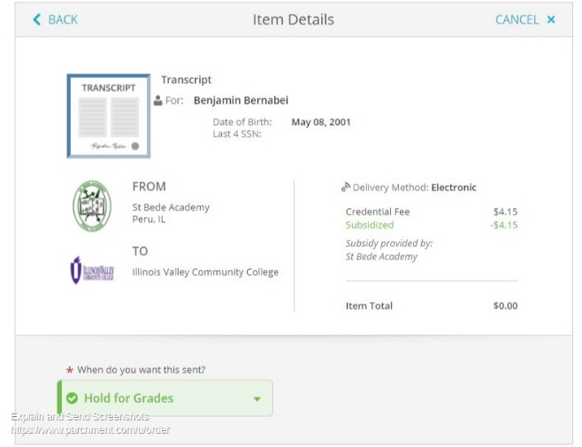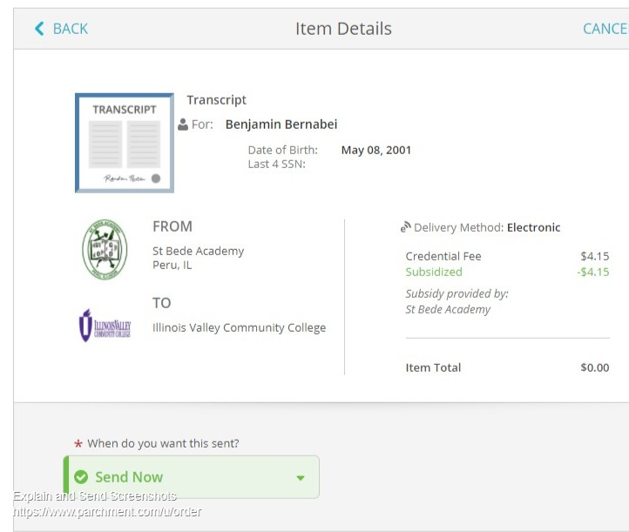



1. 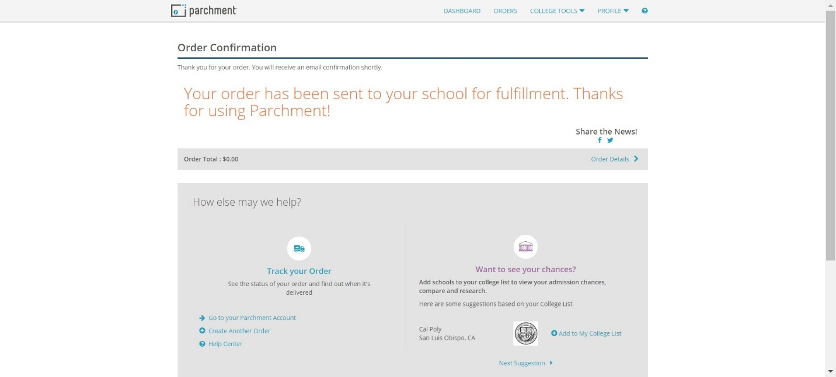**Follow the prompts until you see that your order is complete**



1. **Your transcript will be immediately available for the college to download.**
2. **Please let me know a.s.a.p. if you need help with this process.**

Ms. Theresa Bernabei, [tbernabei@st-bede.com](mailto:tbernabei@st-bede.com)

counseling office: 815-223-3140 x211